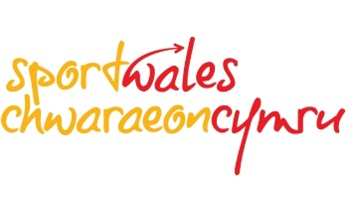
Sport Wales Welsh Language Standards Annual Report – 2018/19
Introduction
The Welsh Language (Wales) Measure 2011 establishes a legal framework to impose duties on persons to comply with statutory standards relating to the Welsh language. The standards replaced the Welsh Language Act 1993.
After a period of consultation between Sport Wales and the Welsh Language Commissioner, new Welsh Language Standards came into place for Sport Wales on January 25th 2017.
This document is Sport Wales’s Annual Report for 2018/19 on our performance against our new Welsh Language Standards, as well as providing details of partnership work we have completed over the last 12 months.
We are committed to ensuring we meet the duties placed upon us and recognise the role that sport can play in supporting the development of Welsh in the community.

Key Highlights – 2018/19
Urdd
We have continued to partner with the Urdd, investing significantly on an annual basis with this year’s investment being £341,868. The budget continues to be used to develop opportunities across Wales for young people to take part in sporting opportunities through the medium of Welsh. Investment is put into the community programme, focussing mainly on children of primary school age. Focus areas include community club development, family opportunities, appropriate competitive opportunities and workforce development.
💡The Urdd’s apprentice scheme continues to go from strength to strength. The scheme ensures increased sporting provision throughout Wales and enables young people to gain recognised Qualifications (NVQ Level 2 Leading Activity and NVQ Level 3 Sports Development). This year has seen apprentices deployed within new areas of Wales, ensuring the development of more and better opportunities for children and young people. In During 2018-19 the Urdd had 30 apprentices on the Urdd Apprenticeship programme and 30 external apprentices receiving training from the Urdd Sports Department.

Gemau Cymru
We are a key player in the current Gemau Cymru initiative, investing £60,000 in 2018/19 in the bilingual multi-sport event, launched in 2011 as part of a Wales-wide London 2012 Legacy project. The event was established as a partnership between Welsh Government Major Events Unit (MEU), National Governing Bodies of Sport (NGBs) and Sport Wales, with Urdd Gobaith Cymru being commissioned as the delivery partner. It provides an opportunity for talented young athletes to compete in a high-profile multi-sport event while experiencing an athlete village environment.

Some of the key outputs in 2018/19:
• The games have contiued to grow annually with over 1200 young athletes in Wales participating
• 9 sports competed in Gemau Cymru 2018 • The majority of the games took part at various sporting venues across Cardiff
• Bala was established as the new venue for triathlon and new competition, open water swim
• Cardiff University, Talybont campus was the location for the athletes village where over where over 220 competitors stayed
• Free transport was provided for competitors across Wales to attend and return from the games
• 9 talented athletes were chosen as ambassadors to the games and provided inspiration and support for athletes

Marketing
Bilingual marketing campaigns have been at the centre of our work.
A new full bilingual Vision for Sport in Wales was launched with a new web resource and other supporting materials.
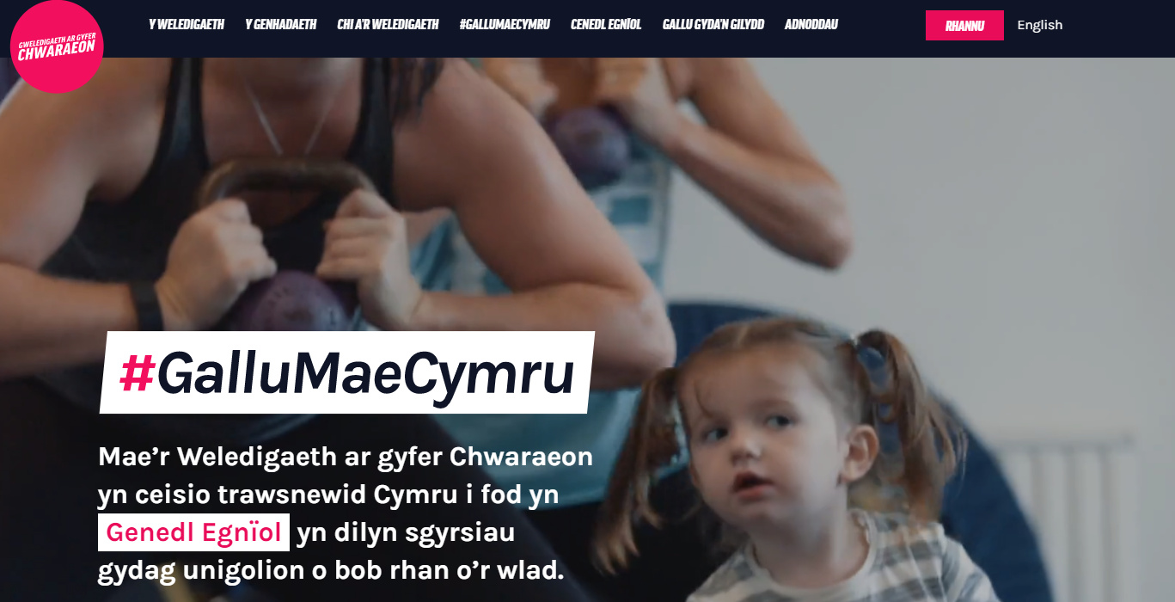
Other campaigns included the School Sport Survey and Community Sport and Activity Programme.
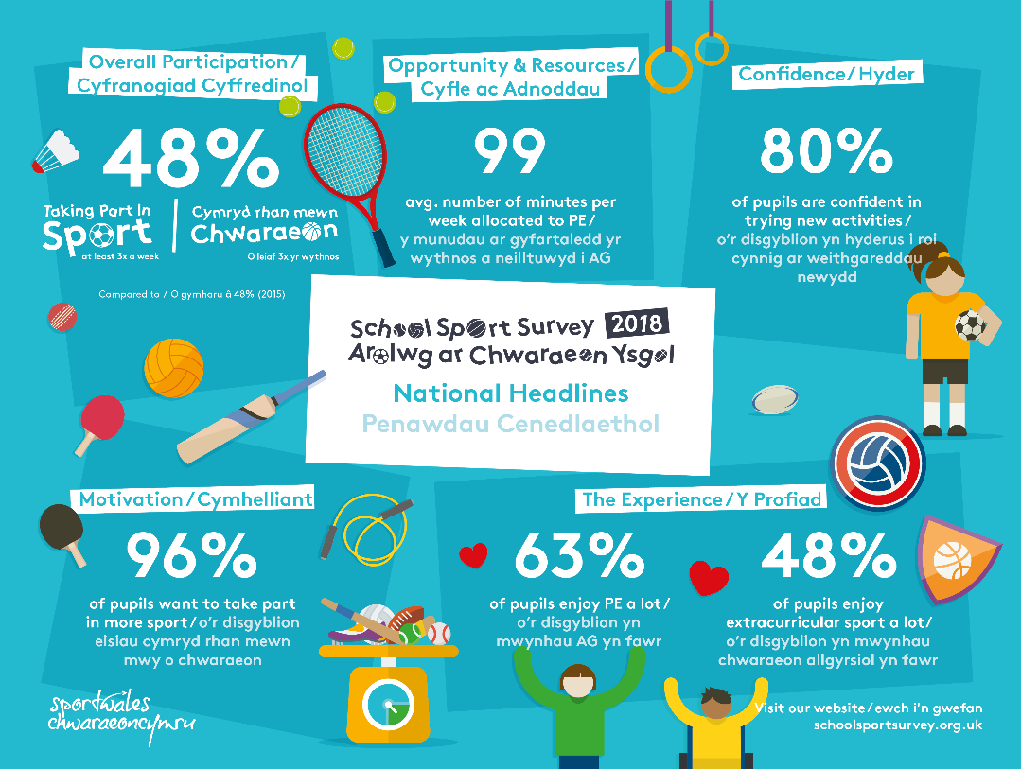

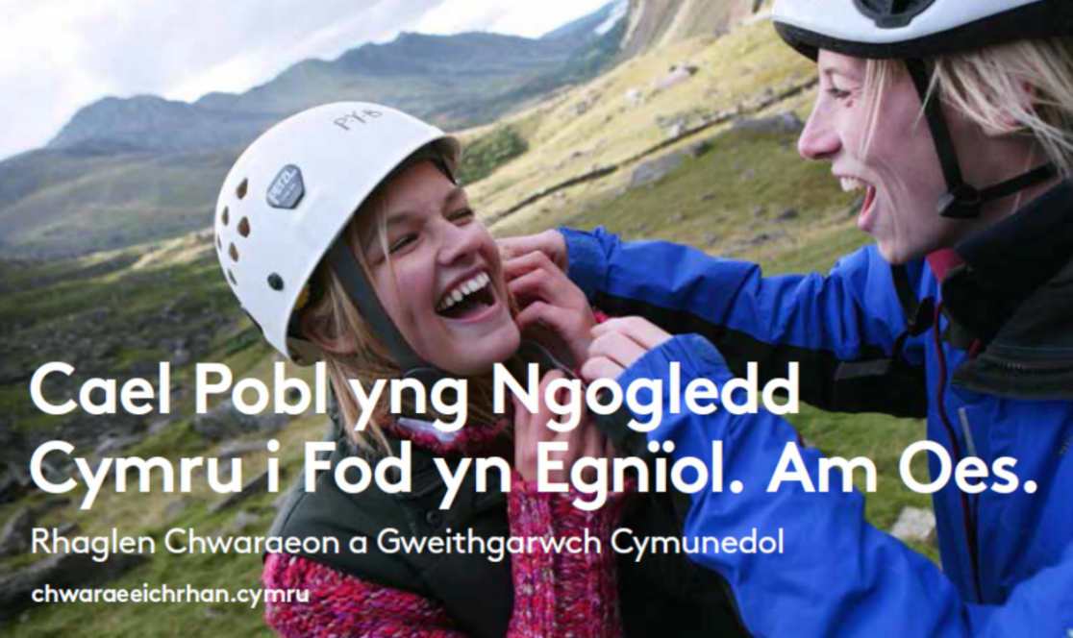
For our marketing and promotion work, we translated around 500,000 words from English to the Welsh Language.
Community Grants
We work proactively to develop sport for people bilingually.
Of the 1,397 Community Chest and Development Grants awarded, 56 are from organisations that say that they provide sporting activity entirely through the medium of Welsh, whilst 264 organisations said they use it partially.

219 organisations indicated on their application forms that their project will increase the use of Welsh language in their organisation with 164 organisations stating that they weren’t currently providing sporting activity through the medium of Welsh prior to the project.

 | Before | After | Increase
No. of sessions delivered in Welsh (fully) | 719 | 1120 | 401
No. of Welsh Coaches (fully) | 420 | 689 | 269
No. of sessions delivered in Welsh (bilingually) | 3383 | 4745 | 1362
No. of Welsh Coaches (bilingual) | 880 | 1331 | 451

Our Duties
The potential impact of those who wish to use the Welsh Language is considered and summarised as a standard section of Sport Wales impact assessment and Board paper template.

For 2019/20 Sport Wales plans to produce one integrated report that will report against statutory duties, including the Welsh Language.

Sport Wales has joined a group of national bodies joining together to develop a cultural strategy for Wales improving access to cultural opportunities, celebrating Welsh Culture and the Welsh language.

Sport Wales is working collaboratively with National Bodies including the Welsh Language Commissioner’s Office to develop a suite of high-level equality objectives for national bodies to unite behind.

In November 2018 Sport Wales Board received an update session regarding Sport Wales Statutory requirements under the Equality Act, Future Generations Act and Welsh Language Standards. A resource card to support Board members with effective questioning around statutory duties has been made available in English and Welsh.

Standards Compliance
For the purpose of this report we will provide a summary of actions taken to adhere to ‘Class of Standards’ such as Service Delivery, Policy Making and Operational etc. This report is by no means exhaustive and does not provide an update of our adherence to every Standard applicable to us, but aims to provide both the public and the Commissioner with insight into the actions taken to comply with the Standards.
Service Delivery:
• External communication, be it publications, adverts, promotional materials etc, which are displayed or distributed to the public are fully bilingual and the Welsh language is treated no less favourably.
• Invitations to meetings / events which are open to the public are bilingual.
• All documents produced for external consumption including corporate business plans, annual accounts etc, are produced bilingually and the Welsh language is treated no less favourably than the English language.
• Any application forms we produce are bilingual and our Online Grants Management System enables grant applicants to not only apply through the medium of Welsh but also manage the entire process (including correspondence) through their language of choice.
• Our corporate website and micro-sites are fully bilingual, and we use a language ’toggle’ system to enable users to switch between viewing pages in English and Welsh with each page on the website having both an English and Welsh version. We also have Welsh URL’s.
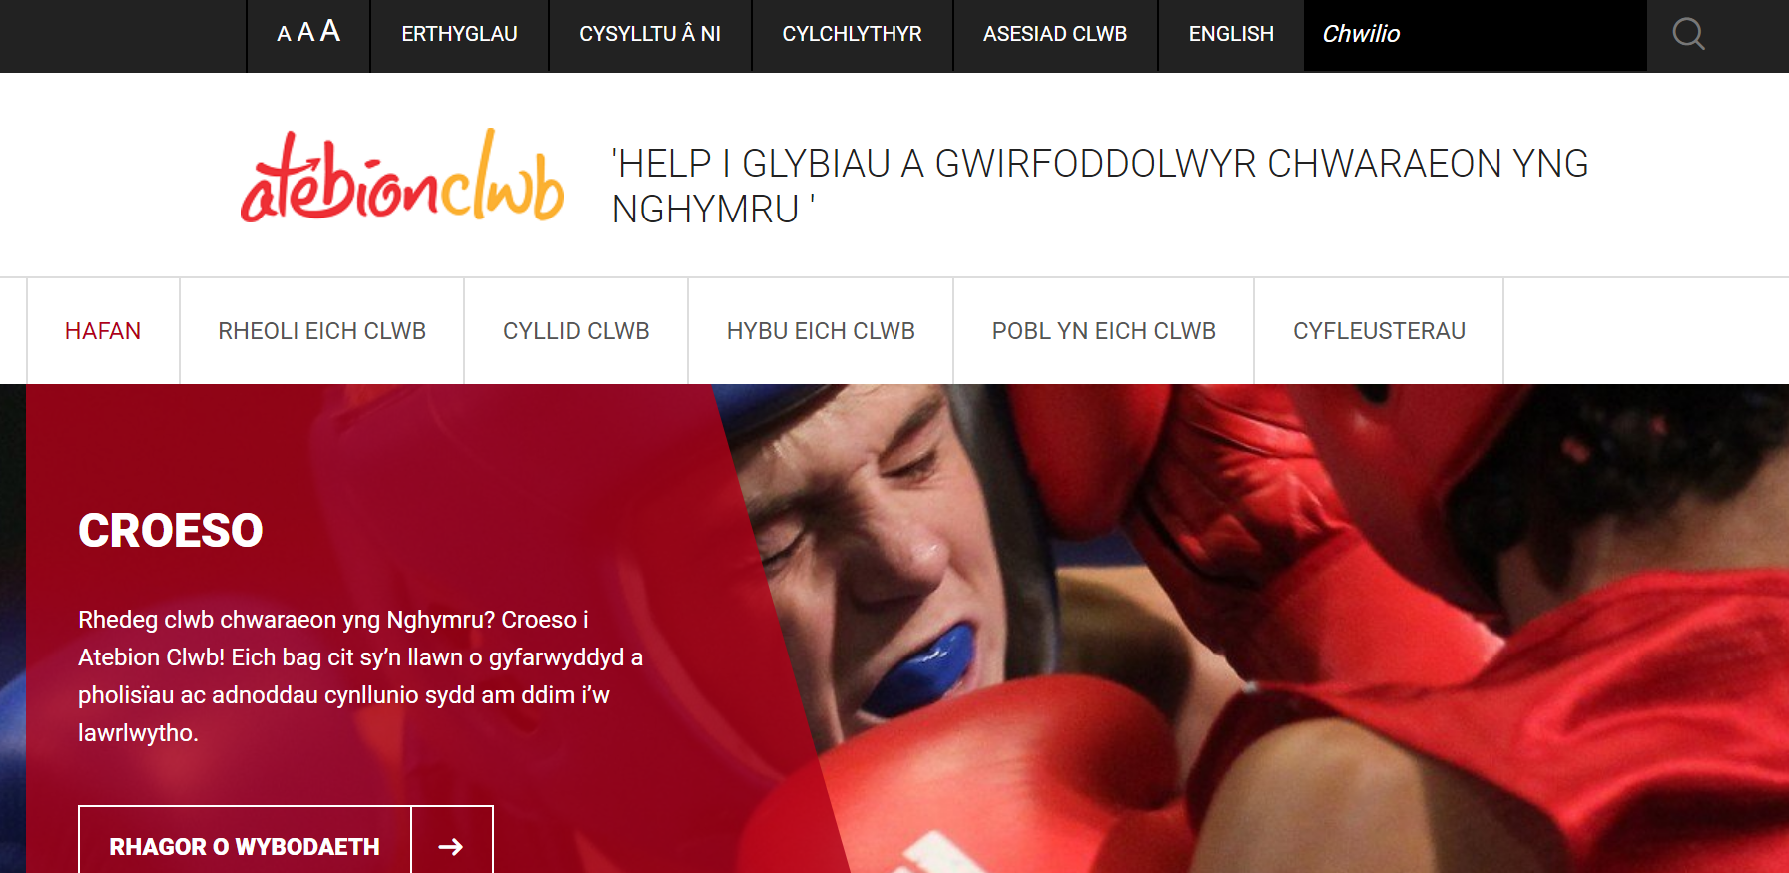

• Any apps and digital services we develop are fully bilingual, have Welsh interfaces and the Welsh versions are fully functional.
• On social media we do not treat the Welsh Language any less favourably and if a member of the public engages with us on social media in Welsh then we engage with them through their language of choice.
• All signage in both of our National Centres and at our events are bilingual. Previously we developed signage with the English text first but new signage has been purchased (bespoke in many cases) ensuring that the Welsh will be read first.
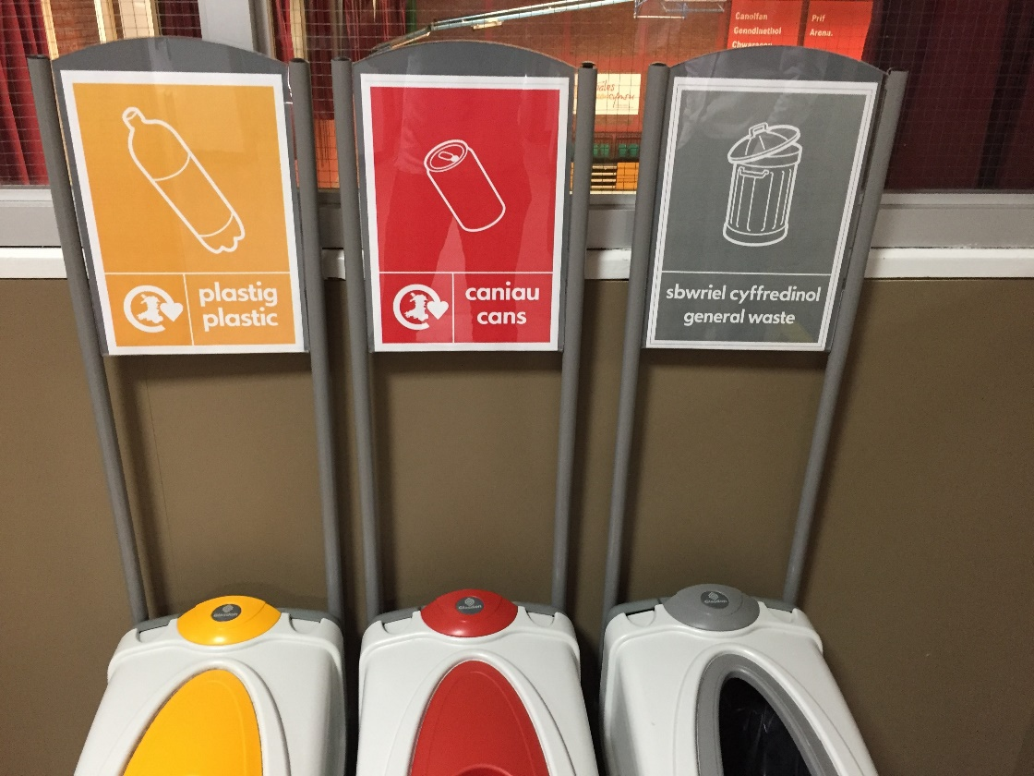
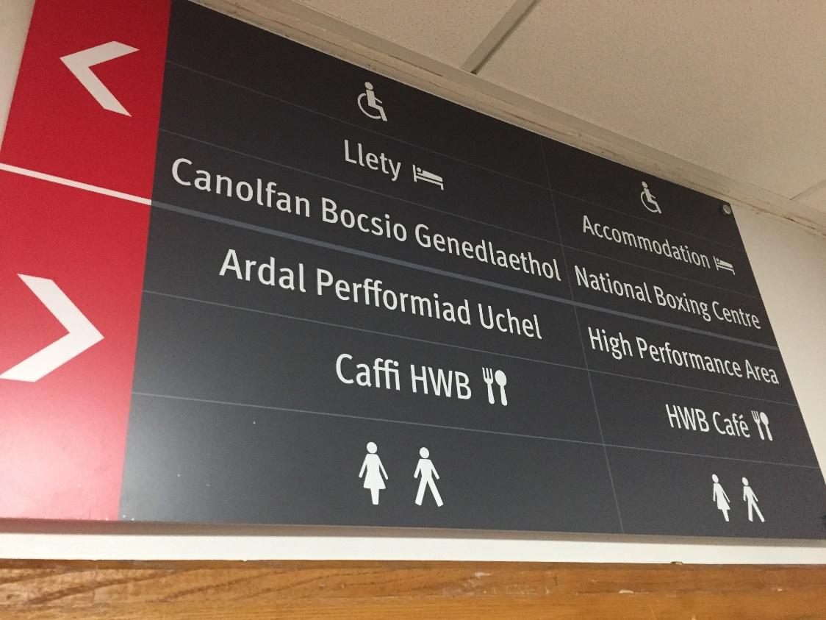
• We have developed a process for all staff on how to deal with Welsh language enquiries and this process is detailed on the Welsh Language pages of our corporate intranet.
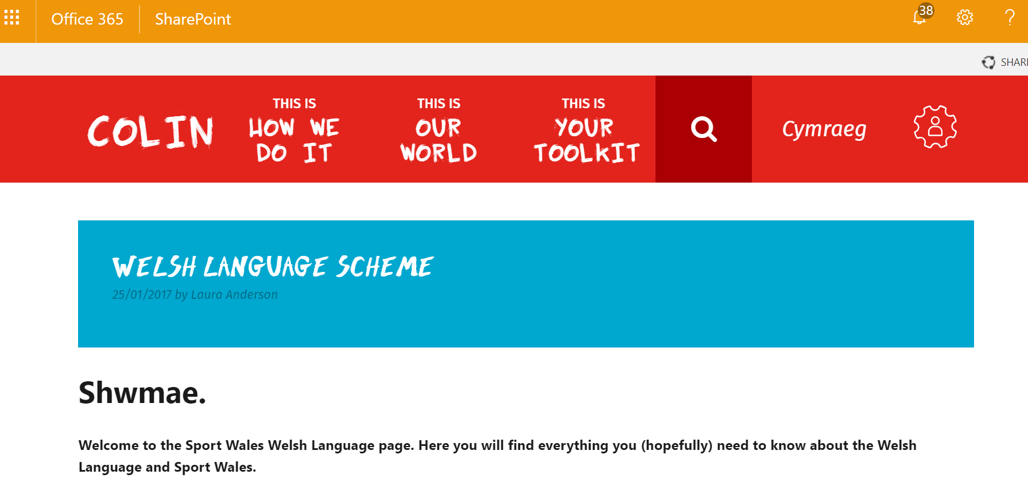
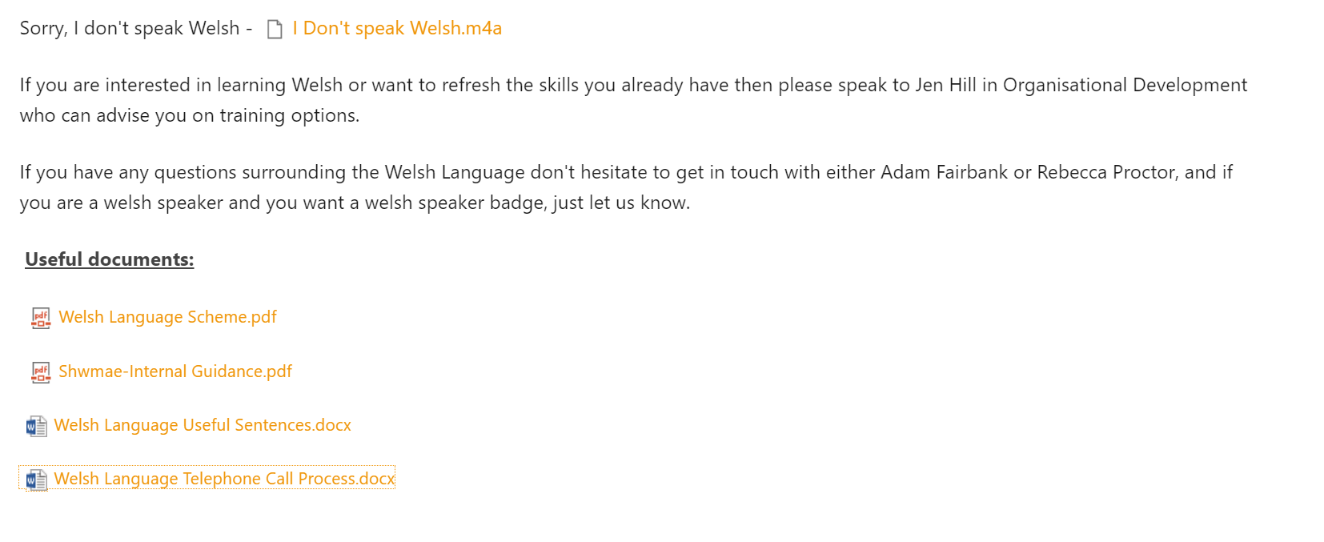

Policy Making:
• The Welsh Language is included within our Equality Impact Assessment process which must be completed on all new projects / strategies / policies we develop. Therefore, the impact of any piece of work on the Welsh Language is considered alongside other equality streams including BME, LGBT and social deprivation.
Operational:
Operational:
• We have continued to develop our Intranet site to contain links through to our current Welsh language Scheme as well our internal policy, useful Welsh sentences and even audio clips of Welsh greetings to aid staff learning.
• All vacancies now have Welsh language as a desirable criteria. There were 26 vacancies across the 2018/19 financial year.
All our posts list Welsh Language skills as highly desirable.
• As part of an annual employee details update, all staff were asked whether they wished to receive written correspondence regarding their employment in Welsh. No staff requested this.
• Our staff handbook which details our corporate policies covering everything from health and safety to performance and absence management and workplace benefits is bilingual.
• All staff were made aware of the opportunity to make complaints through the medium of Welsh and that the whole complaint process will be completed through the language of choice.
• All staff have the opportunity to receive Welsh language training during working hours, if that is how they choose to learn.
Following our launch of Welsh language training 2016, a number of employees have continued to advance their Welsh language skills during this period, with the following breakdown in terms of competency levels: Entry - 2, Foundation - 4, Advanced – 1. We plan to relaunch welsh language training in 2020 with taster sessions for staff.

• All email signatures are managed centrally by our ICT department and are bilingual.
• All our job adverts are bilingual and all supporting materials for vacancies such as application forms and job specifications are bilingual.
• When an applicant applies for a vacancy in Welsh, the whole recruitment process will be completed through their language of choice.
Record keeping:
• We keep a record each year of the number of complaints we received, if any, linked to the Welsh Language and our adherence to the Welsh Language Standards. During the 2018/19 financial year we did not receive a formal complaint regarding use of the Welsh Language.
• We keep a record of the number of Welsh speakers within Sport Wales. In 2018/19 we had the following:
Welsh Speaker | %
Fluent | 7
Partial | 6.5
Beginner | <5
Non welsh speaker | 23.8
Not declared | 59.4

Supplementary – Service Delivery / Policy Making / Operational / Record-keeping:
• Our ‘Welsh Language Scheme’ (http://sport.wales/media/1890653/welsh_language_corporate_doc_english.pdf) includes all of our standards and can be found on our website
• Details on how we would manage a complaint related to the Welsh Language are included within the Welsh Language Scheme mentioned above.
• If requested we will happily provide any information with regards to our adherence to any of the standards with which we are under a duty to comply.
While we have made significant process in developing and promoting the Welsh language, there are many areas we want to take forward. We will work proactively on these in our planning and report on progress regularly.

